**Assignment** :1

|  |  |  |  |  |  |  |
| --- | --- | --- | --- | --- | --- | --- |
| **(a) Create the following table: DEPARTMENT** | | | | | |  |
|  |  |  |  |  |  |  |
|  |  | **Column Name** | | **Data Type** | **Size** | **Constraints** |
|  |  | DeptCode | | Varchar2 | 4 | Primary key |
|  |  | DeptName | | Varchar2 | 40 | Not null |
|  |  | StudentAllotted | | Number | 4 | Not null |
| **CREATE TABLE DEPARTMENT(DeptCode Varchar2(4) PRIMARY KEY,DeptName Varchar2(15) NOT NULL,Student_allotted Number(4) NOT NULL);**    **(b) Display the structure of the table Department**  **DESC DEPARTMENT;** | | | | | |  |
|  | **(c)Drop a table.**  **DROP TABLE DEPARTMENT;** | | |  |  |  |
| **(d) Insert data into the table.**  **INSERT INTO DEPARTMENT VALUES('CSE','ComputerScience andEngineering',120);**  **INSERT INTO DEPARTMENT VALUES( 'ECE','ElectronicsandCommEngineering',120);**  **INSERT INTO DEPARTMENT VALUES( 'IT','InformationTechnology',60);**  **INSERT INTO DEPARTMENT VALUES( 'EE','ElectricalEngineering',60);** | | | | |  |  |
| **(e)** | **Create the following table: STUDENT** | | | |  |  |
|  |  |  |  |  |  |  |
|  |  |  | **Column Name** | **Data Type** | **Size** | **Constraints** |
|  |  |  | RollNo | Number | 6 | Primary Key |
|  |  |  | Name | Varchar2 | 25 | Not null |
|  |  |  | Address | Varchar2 | 40 | Not null |
|  |  |  | PhoneNo | Number | 10 |  |
|  |  |  | YearOfAdm | Number | 4 | Not null |
|  |  |  | DeptCode | Varchar2 | 4 | Not null |
|  |  |  | Semester | Varchar2 | 4 | Not null |
|  |  |  | BirthDate | Date |  | Not null |



CREATE TABLE STUDENT(ROLLNO INT(6) PRIMARY KEY,NAME VARCHAR(25) NOT NULL,ADDRESS VARCHAR(40) NOT NULL,PHONENO INT(10),YEAROFADM INT(4) NOT NULL,DEPTCODE VARCHAR(4) NOT NULL,SEMESTER VARCHAR(4) NOT NULL,BIRTHDATE DATE);



1. **Display the structure of the table Student.**

**DESC STUDENT;**

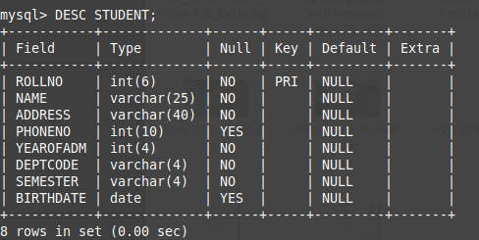

1. **Insert data into the table.**

**INSERT INTO STUDENT VALUES(1001,'ANKIT DAS','VIP Road, Kolkata',9830675221,2017,'CSE','SEM5','10.02.1999');**

**INSERT INTO STUDENT VALUES(1002,'MOINAK GHOSH','MG Road, Kolkata',7988822201,2015,'CSE','SEM5','01.05.1998');**

**INSERT INTO STUDENT VALUES(1003,'PARIMAL KUMAR','NSB Road, Birati',8099922211,2016,'CSE','SEM5','17.03.2001');**

**INSERT INTO STUDENT VALUES(2001,'SANCHITA SINGH','Tegharia, Kolkata',9999110011,2017,'ECE','SEM5','20.10.2000');**

**INSERT INTO STUDENT VALUES(2002,'ANANYA BISWAS','MG Road, Howrah',7667880010,2017,'ECE','SEM5','05.11.2001');**

**INSERT INTO STUDENT VALUES(2101,'ASHISH KUMAR','Baguiati, Kokata',6544332121,2017,'ECE','SEM5','17.09.2001');**

**INSERT INTO STUDENT VALUES(1029,'NAITIK PRASAD','KGR path, Belgharia',Null,2018,'CSE','SEM3','08.10.2003');**

**INSERT INTO STUDENT VALUES(4011,'SATNAM JYOTI','Garia, Kolkata',8933322125,2018,'IT','SEM3','21.09.2002');**

**INSERT INTO STUDENT VALUES(3002,'SAURAV ROY','Chandannagar',Null,2017,'EE','SEM5','23.08.2000');**

**INSERT INTO STUDENT VALUES(3005,'MOHAMMAD AZIB','Saltlake',7910000666,2017,'EE','SEM5','20-05-2001');**

**INSERT INTO STUDENT VALUES(2004,'NIKHIL SINGH','Central Howrah',NULL,2016,'ECE','SEM5','21-06-1999');**

**INSERT INTO STUDENT VALUES(1023,'SAMPRIKTA BISWS','Barrackpore',8877565643,2018,'CSE','SEM3','13.12.2003');**

**INSERT INTO STUDENT VALUES(1011,'RAHUL KHAN','Jadavpur,Kolkata',Null,2017,'CSE','SEM5','07.07.2001');**

**INSERT INTO STUDENT VALUES(1060,'SHUBHAM','Sealdah,Kolkata',9833221098,2017,'CSE','SEM3','09.08.2003');**

**INSERT INTO STUDENT VALUES(2009,'GAURAV PRAKASH','Saltlake',NULL,2018,'ECE','SEM3','10.04.2004');**

**INSERT INTO STUDENT VALUES(3008,'RAHUL JOSHI','AB block Saltlake',9980765123,2018,'EE','SEM3','20.06.2003');**

**INSERT INTO STUDENT VALUES(4200,'MRIGENDRA','Belur,Howrah',NULL,2019,'IT','SEM1','01.07.2004');**

**INSERT INTO STUDENT VALUES(1500,'SUBARNA MITRA','Gariahat,Kolkata',6987654322,2017,'CSE','SEM3','02.01.2003');**

**INSERT INTO STUDENT VALUES(1101,'AMARITA DEV',' DEVCG Block, Saltlake',NULL,2019,'CSE','SEM1','06.01.2004');**

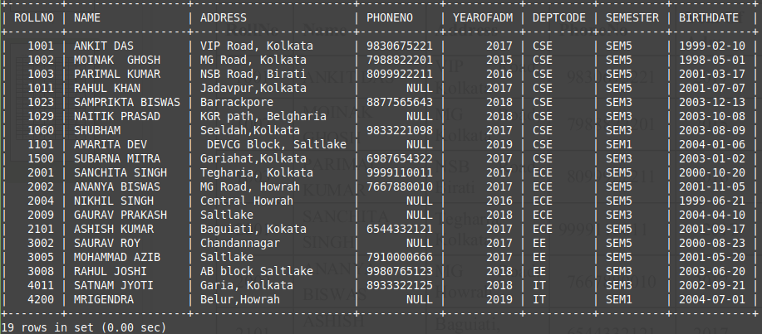

**Table: DEPARTMENT**

|  |  |  |
| --- | --- | --- |
| **DEPTCODE** | **DEPTNAME** | **STUDENTALLOTTED** |
|  |  |  |
| CSE | Computer Science and | 120 |
|  | Engineering |  |
| ECE | Electronics and Communication | 120 |
|  | Engineering |  |
| IT | Information Technology | 60 |
| EE | Electrical Engineering | 60 |

**Table: STUDENT**

|  |  |  |  |  |  |  |  |  |  |
| --- | --- | --- | --- | --- | --- | --- | --- | --- | --- |
| **RollNo** | **Name** | **Address** | | **PhoneNo** | **YearOf** | **Dept** | **Semester** | **BirthDate** |  |
| **Adm** | **Code** |  |
|  |  |  |  |  |  |  |  |
| 1001 | ANKIT DAS | VIP | Road, | 9830675221 | 2017 | CSE | SEM5 | 10-02-1999 |  |
| Kolkata |  |  |
|  |  |  |  |  |  |  |  |  |
| 1002 | MOINAK | MG | Road, | 7988822201 | 2015 | CSE | SEM5 | 01.05.1998 |  |
| GHOSH | Kolkata |  |  |
|  |  |  |  |  |  |  |  |
| 1003 | PARIMAL | NSB | Road, | 8099922211 | 2016 | CSE | SEM5 | 17.03.2001 |  |
| KUMAR | Birati |  |  |
|  |  |  |  |  |  |  |  |
| 2001 | SANCHITA | Tegharia, | | 9999110011 | 2017 | ECE | SEM5 | 20.10.2000 |  |
| SINGH | Kolkata |  |  |
|  |  |  |  |  |  |  |  |
| 2002 | ANANYA | MG | Road, | 7667880010 | 2017 | ECE | SEM5 | 05.11.2001 |  |
| BISWAS | Howrah |  |  |
|  |  |  |  |  |  |  |  |
| 2101 | ASHISH | Baguiati, | | 6544332121 | 2017 | ECE | SEM5 | 17.09.2001 |  |
| KUMAR | Kokata |  |  |
|  |  |  |  |  |  |  |  |
| 1029 | NAITIK | KGR | path, |  | 2018 | CSE | SEM3 | 08.10.2003 |  |
| PRASAD | Belgharia | |  |  |
|  |  |  |  |  |  |  |
| 4011 | SATNAM | Garia, |  | 8933322125 | 2018 | IT | SEM3 | 21.09.2002 |  |
| JYOTI | Kolkata |  |  |
|  |  |  |  |  |  |  |  |
| 3002 | SAURAV ROY | Chandannagar | |  | 2017 | EE | SEM5 | 23.08.2000 |  |
| 3005 | MOHAMMAD | Saltlake |  | 7910000666 | 2017 | EE | SEM5 | 20.05.2001 |  |
| AZIB |  |  |
|  |  |  |  |  |  |  |  |  |
| 2004 | NIKHIL | Central |  |  | 2016 | ECE | SEM5 | 21.06.1999 |  |
| SINGH | Howrah |  |  |  |
|  |  |  |  |  |  |  |  |
| 1023 | SAMPRIKTA | Barrackpore | | 8877565643 | 2018 | CSE | SEM3 | 13.12.2003 |  |
| BISWAS |  |
|  |  |  |  |  |  |  |  |  |
| 1011 | RAHUL KHAN | Jadavpur, | |  | 2017 | CSE | SEM5 | 07.07.2001 |  |
| Kolkata |  |  |  |
|  |  |  |  |  |  |  |  |  |
| 1060 | SHUBHAM | Sealdah, | | 9833221098 | 2017 | CSE | SEM3 | 09.08.2003 |  |
| Kolkata |  |  |
|  |  |  |  |  |  |  |  |  |
| 2009 | GAURAV | Saltlake |  |  | 2018 | ECE | SEM3 | 10.04.2004 |  |
| PRAKASH |  |  |  |
|  |  |  |  |  |  |  |  |  |
| 3008 | RAHUL JOSHI | AB | block, | 9980765123 | 2018 | EE | SEM3 | 20.06.2003 |  |
| Saltlake |  |  |
|  |  |  |  |  |  |  |  |  |
| 4200 | MRIGENDRA | Belur,Howrah | |  | 2019 | IT | SEM1 | 01.07.2004 |  |
| 1500 | SUBARNA | Gariahat, | | 6987654322 | 2017 | CSE | SEM3 | 02.01.2003 |  |
| MITRA | Kolkata |  |  |
|  |  |  |  |  |  |  |  |
| 1101 | AMARITA | CG | Block, |  | 2019 | CSE | SEM1 | 06.01.2004 |  |
| DEV | Saltlake |  |  |  |
|  |  |  |  |  |  |  |  |